

PROJECT REPORT
FIT TRACK

YEAR : 2026 – 2027
COLLEGE NAME : K.C.S KASI NADAR COLLEGE OF ARTS & SCIENCE
CODE : UNM203
DEPARTMENT : COMPUTER SCIENCE
PROGRAM : B.C.A
SEMESTER : V
PROJECT SUBMITTED TO: UNIVERSITY OF MADRAS /
VETRI THIRAN PAYIRCHI THITTAM
Course Name : AI Augmented Backend Development with
Node JS and MongoDB

TEAM LEADER:
KRISHNA R
MEMBERS:
1. SHAILESH S
2. THARUN S.J
3. MAGESHWARAN B
4. VETRISELVAN S
GUIDED BY: Mrs. R.PADMADEVI
SPOC NAME: Dr.K. LALITHAKAMESWARI

FitTrack AI – AI-powered personalized fitness recommendations.

Description
The FitTrack AI backend is a secure, scalable, and AI-powered RESTful application developed to simplify workout tracking and provide intelligent fitness recommendations. Developed with Node.js, Express.js, MongoDB, and Mongoose, the backend provides REST APIs for secure authentication, workout management and search, and AI-supported fitness guidance.
The project uses the Model-View-Controller (MVC) architecture to keep the application modular, maintainable, and scalable. JSON Web Tokens (JWT) provide user authentication, while bcrypt.js hashes passwords before they are stored in MongoDB. Middleware verifies the JWT for each protected API request before granting access to private resources.
A key feature is Google Gemini AI integration, which recommends workouts based on the user's age, fitness goals, and experience. The AI module also produces fitness insights from workout statistics, including completed sessions, average workout duration, and calories burned.
The backend provides consistent JSON responses for integration with web, mobile, and third-party applications. Error handling, input validation, protected routes, and modular services help make the application secure, reliable, and easier to extend.

Scenario-Based Case Study

Background
Rahul regularly exercises and is interested in fitness, but he records each workout manually in notebooks and spreadsheets. Although he follows a consistent routine, he struggles to organize his workout history, track progress, and check whether his activities match his fitness goals. He also has little professional guidance when choosing exercises suited to his current fitness level.

Problem
- Difficulty maintaining a centralized record of workouts.
- Manual tracking leads to inaccurate workout history.
- No secure user authentication for personal fitness records.
- Unable to search previous workouts efficiently.
- No personalized workout recommendations.
- No insights regarding overall workout performance.
- Time-consuming manual calculation of calories burned and workout duration.

Solution
The FitTrack AI provides a centralized backend system where users can securely register, authenticate, and manage workout records. Through RESTful APIs, users can add, edit, delete, retrieve, and search workout records. With Google Gemini AI integration, the application examines user details and workout statistics to create tailored workout recommendations and fitness insights.
The backend uses security practices such as JWT authentication, password hashing, middleware authorization, centralized error handling, and MongoDB schema validation.

Usage

User Usage
Users can register through the registration endpoint and securely log in with their email and password. After login is verified, the backend creates a JWT that grants access to protected APIs.
Using authenticated APIs, users can:
- Create new workout records.
- View all previously completed workouts.
- Retrieve a workout by its unique identifier.
- Update existing workout information.
- Delete unwanted workout records.
- Search workouts using workout name, category, or workout date.
- Generate AI-powered workout recommendations.
- Obtain AI-generated fitness insights based on workout statistics.

AI Usage
A dedicated service layer handles communication between the AI module and Google Gemini.
Users provide information such as:
- Age
- Fitness Goal
- Experience Level
Gemini analyzes the supplied details and returns:
- Personalized workout plan
- Weekly exercise suggestions
- Beginner/Intermediate/Advanced recommendations
- Motivational guidance
- Safety tips
Users can also submit workout statistics such as:
- Total Workouts
- Average Workout Duration
- Total Calories Burned
The AI module evaluates these values to generate personalized fitness insights.

Outcome
The FitTrack AI backend simplifies fitness tracking by reducing manual record keeping and offering recommendations based on user activity. Secure authentication limits access to personal workout data to authorized users, while AI suggestions help them improve their exercise routines.
The modular MVC design supports easier maintenance and future expansion. The application may later support nutrition tracking, BMI calculations, wearable integration, workout reminders, and fitness dashboards without major architectural changes.

1. Software Requirements
The FitTrack AI requires the following software components for development and execution.Operating System: Windows 10/11, macOS, or Linux (supports cross-platform operations).
- Node.js (v16 or above): Runtime ecosystem running server logic and routing infrastructure.
- npm (v8 or above): Node package manager to control operational dependencies.
- Express.js: Lightweight routing web framework to construct backend RESTful entry points.
- MongoDB: NoSQL database used to store user profiles and workout records.
- Postman: API verification toolkit to assert schema validation responses across administrative route shields.
- Code Editor: Visual Studio Code or similar IDE environment.

2. Hardware Requirements
- Processor: Intel Core i5 (8th Gen or above) / AMD Ryzen 5 or equivalent.
- RAM: 8 GB minimum (16 GB recommended for concurrent instances of MongoDB, processing layers, and execution nodes).
- Storage: 1 GB of available disk workspace.

Epic 1: Project Architecture


The FitTrack AI follows a layered architecture based on the MVC (Model–View–Controller) design pattern. Routing, business logic, database access, middleware, and AI services are divided into separate modules, making the project easier to maintain and scale.
When a client sends an HTTP request, the Express server receives it and directs it to the appropriate route. Requests to protected routes pass through authentication middleware, which verifies the JWT before granting access. Controllers handle validated requests and call the required business logic or AI services. Mongoose models manage database operations, while a separate service layer connects to Google Gemini AI. The controller then returns a structured JSON response to the client.
This layered design improves modularity, security, and maintainability by giving each component a specific responsibility.

Overall Architecture Components
- Client Application (React / Mobile App / Postman)
- Express Server
- API Routes
- Authentication Middleware
- Controllers
- Services
- Google Gemini AI Service
- MongoDB Database
- Mongoose Models
Each component communicates through well-defined interfaces, ensuring loose coupling and easier future enhancements.

Components Definition
The FitTrack AI follows a modular backend architecture in which every component performs a dedicated responsibility. The separation of concerns ensures maintainability, scalability, and efficient execution of requests. Each request passes through multiple layers before reaching the database or AI service, ensuring secure and reliable processing.

1. Client Layer (Frontend/API Consumer)
The Client Layer is the application's starting point. It can be a React application, mobile application, or API testing tool such as Postman. The client sends HTTP requests to the backend and receives JSON responses.

Responsibilities
- Sends API requests.
- Displays workout information.
- Stores JWT token after login.
- Invokes AI recommendation APIs.
- Displays success and error responses.

APIs Accessed
- Authentication APIs
- Workout APIs
- AI Recommendation APIs
- AI Fitness Insight APIs

2. Express Server Gateway
The Express server serves as the application's central gateway. It receives requests, configures middleware, parses request bodies, enables CORS, and directs requests to the appropriate controllers.

Responsibilities
- Starts HTTP server
- Parses JSON requests
- Enables Cross-Origin Resource Sharing (CORS)
- Registers application routes
- Connects middleware
- Handles centralized errors

Example Responsibilities
- Receive HTTP Request
- Validate Request Format
- Forward Request to Routes
- Return JSON Response

3. Authentication Middleware
Authentication middleware secures protected APIs by validating the JSON Web Token (JWT). Each protected request must contain a valid Authorization header.

Responsibilities
- Read Authorization Header
- Extract JWT Token
- Verify JWT Signature
- Decode User Information
- Attach User Information to Request
- Reject Unauthorized Requests

Benefits
- Prevents unauthorized access
- Secures workout information
- Allows only authenticated users to access protected APIs
- Eliminates repeated authentication logic inside controllers

4. Route Layer
Routes specify the API endpoints and map incoming HTTP requests to controller methods. Each route represents a specific functionality of the system.

Authentication Routes
- Register User
- Login User
- User Profile

Workout Routes
- Add Workout
- Get All Workouts
- Search Workouts
- Get Workout by ID
- Update Workout
- Delete Workout

AI Routes
- Workout Recommendation
- Fitness Insights

5. Controller Layer
Controllers manage the application's business logic. They receive routed requests, validate input, call services or database operations, and return standardized JSON responses.

Authentication Controller
Responsible for:
- User Registration
- User Login
- User Profile Retrieval

Workout Controller
Responsible for:
- Creating Workout Records
- Retrieving Workout Records
- Updating Workouts
- Deleting Workouts
- Searching Workouts

AI Controller
Responsible for:
- Sending prompts to Google Gemini
- Receiving AI-generated recommendations
- Returning AI responses to clients

6. Service Layer
The Service Layer contains reusable logic that can be used by multiple controllers.

Gemini AI Service
Responsible for:
- Preparing prompts
- Sending prompts to Google Gemini
- Receiving AI-generated responses
- Returning formatted recommendations

JWT Service
Responsible for:
- Creating JWT Tokens
- Configuring Token Expiry
- Verifying User Identity

Password Service
Responsible for:
- Hashing Passwords
- Comparing Passwords During Login

7. Database Layer
MongoDB stores the application's persistent data. Mongoose is an Object Data Modeling (ODM) library that simplifies communication between Node.js and MongoDB.

Collections
- Users Collection
- Workouts Collection

Advantages
- Flexible Schema
- High Performance
- Easy Data Retrieval
- Scalable Architecture

Entity Relationship (ER) Diagram Description
The FitTrack AI backend uses two main collections connected through a one-to-many relationship.


1. User Entity
The User entity contains account authentication and profile details.

Attributes
Field | Type | Description
_id | ObjectId | Primary Key
name | String | User Name
email | String | Unique Email Address
password | String | Encrypted Password
createdAt | Date | Record Creation Time
updatedAt | Date | Last Updated Time

Constraints
- Email must be unique.
- Password is encrypted using bcrypt.
- Name is mandatory.
- JWT token is generated after successful login.

2. Workout Entity
The Workout entity contains workout details for each authenticated user.

Attributes
Field | Type | Description
_id | ObjectId | Primary Key
User | ObjectId | References User Collection
WorkoutName | String | Workout Name
Category | String | Workout Category
Duration | Number | Duration (Minutes)
CaloriesBurned | Number | Calories Burned
WorkoutDate | Date | Workout Date
CreatedAt | Date | Created Timestamp
UpdatedAt | Date | Updated Timestamp

Relationship

User → Workout
Relationship Type: One-to-Many
One user can create several workout records, but each workout belongs to a single authenticated user.
Example:
John Doe
- Morning Running
- Evening Jogging
- Upper Body Strength
- Cycling Session
The relationship is represented by the user field in the Workout schema, which stores the corresponding user's ObjectId.

Key Features
The FitTrack AI provides a complete backend solution for workout tracking and AI-assisted fitness guidance.

1. Secure Authentication
The application uses JWT for authentication.
Features include:
- User Registration
- Secure Login
- Password Encryption
- JWT Generation
- Protected APIs

2. Workout Management
Users can carry out all CRUD operations on workout records.
Supported Operations
- Add Workout
- View Workout
- Update Workout
- Delete Workout
Each workout is linked to its authenticated user.

3. Workout Search
Users can search workouts using:
- Workout Name
- Workout Category
- Workout Date
This makes workout history easier to access.

4. Google Gemini Integration
The backend connects to Google Gemini AI to produce personalized workout recommendations.
Input
- Age
- Fitness Goal
- Experience Level
Output
- Weekly Workout Plan
- Suggested Exercises
- Training Tips
- Safety Recommendations

5. AI Fitness Insights
The AI module examines workout statistics.
Input
- Total Workouts
- Average Duration
- Calories Burned
Output
- Performance Analysis
- Improvement Suggestions
- Motivational Advice
- Fitness Progress Summary

6. Centralized Error Handling
The application returns clear JSON error responses for:
- Invalid Credentials
- Missing Authentication Token
- Validation Errors
- Database Errors
- Internal Server Errors

7. RESTful API Design
The backend is built around REST principles.
Supported HTTP Methods
- GET
- POST
- PUT
- DELETE
Responses are returned in JSON format.

8. Modular Architecture
The project separates responsibilities into
- Models
- Controllers
- Routes
- Middleware
- Services
- Configuration
This supports maintainability and scalability.

Roles and Responsibilities
The FitTrack AI backend has one main user role.

Authenticated User

Responsibilities
- Register an account.
- Login securely.
- View profile information.
- Add workout records.
- View workout history.
- Search workouts.
- Update workouts.
- Delete workouts.
- Request AI workout recommendations.
- Request AI fitness insights.

Permissions
Operation | Permission
Register | Yes
Login | Yes
View Profile | Yes
Add Workout | Yes
Get Workouts | Yes
Search Workouts | Yes
Update Workout | Yes
Delete Workout | Yes
AI Recommendation | Yes
Fitness Insights | Yes

User Flow



MVC Architecture Pattern
The FitTrack AI is designed using the Model–View–Controller (MVC) architecture pattern. This architecture divides application logic into separate components to improve organization, maintenance, and scalability.


Model Layer (Data Layer)
The Model Layer describes the application's data structure through Mongoose schemas. It interacts directly with MongoDB to perform database operations.
Models in the project include:
- User Model
- Workout Model
Responsibilities:
- Schema Definition
- Data Validation
- CRUD Operations
- Collection Mapping

View Layer (API Interface)
Because AI FitTrack is a backend REST API, it does not use traditional UI templates. The View Layer consists of API clients such as React apps, mobile apps, or Postman, which send HTTP requests and receive JSON responses.
Responsibilities:
- Send Requests
- Receive JSON Responses
- Display Data
- Handle Client-side Interaction

Controller Layer (Business Logic)
The Controller Layer connects the View and Model. It handles requests, validates input, calls services and models, and sends structured JSON responses to the client.
Responsibilities:
- Request Validation
- Business Logic Execution
- Database Interaction
- AI Service Invocation
- Response Generation
Separating these layers reduces dependencies, simplifies testing, improves readability, and makes future extensions easier.

Epic 2: Project Setup and Configuration
The FitTrack AI project follows a well-structured backend architecture that separates business logic, routing, database operations, middleware, and AI services into individual modules. This modular structure improves readability, maintainability, and scalability, and simplifies debugging and extension.
The backend uses Node.js and Express.js, MongoDB as its main database, and Google Gemini AI for fitness recommendations.

Creating Project Folder

Step 1: Create the Project Folder
Create a new folder with the project name.
AI-FitTrack-API

Step 2: Open the Project
Open the project folder in Visual Studio Code.

Step 3: Create the Server Folder
Inside the project directory, create a folder named:
server
All backend source code will be maintained inside this folder.


Step 4: Initialize Node Project
Open the terminal inside the server folder and execute:
npm init -y
This command generates the package.json file containing project metadata and dependency information.

Step 5: Install Required Packages
Install the required dependencies.
npm install express mongoose dotenv bcryptjs jsonwebtoken cors
Install Nodemon as a development dependency.
npm install --save-dev nodemon

Environment Variables
Sensitive configuration values are kept in the .env file.
Example
PORT=5000

MONGO_URI=mongodb://localhost:27017/aifittrack

JWT_SECRET=your_secret_key

GEMINI_API_KEY=your_google_gemini_api_key
Environment variables help prevent sensitive information from appearing directly in source code.

Epic 3: Backend Development
Backend development centers on REST APIs that let authenticated users manage workouts and use Google Gemini AI.
Different modules work together to handle authentication, workout management, AI integration, and database operations.
Major modules include:
- Server Configuration
- Database Configuration
- Authentication
- Workout Management
- AI Recommendation
- Middleware
- Error Handling

Epic 4: Database Configuration
The FitTrack AI uses MongoDB as its primary NoSQL database for storing user credentials and workout information. Mongoose provides the Object Data Modeling (ODM) layer for communication between the application and MongoDB. Mongoose supports schema validation, middleware, data relationships, and simpler CRUD operations.
The database layer helps maintain data integrity, validate submitted information, and store user details securely.

MongoDB Configuration
MongoDB organizes application data into collections instead of traditional relational tables. The FitTrack AI maintains separate collections for users and workouts.

Database Collections
- Users Collection
- Workouts Collection
Each collection contains JSON-like BSON documents, allowing flexible schemas and efficient data retrieval.

Installing Mongoose
Install Mongoose using npm.
npm install mongoose
Mongoose connects the Node.js application with MongoDB and provides schema definitions, validation, and database methods.

MongoDB Connection
The database connection is set up in config/db.js. This module connects to MongoDB when the application starts.


Responsibilities
- Connect to MongoDB
- Handle Connection Errors
- Display Connection Status
- Export Database Connection

Advantages
- Centralized database configuration
- Reusable connection module
- Automatic connection management
- Simplified error handling

Mongoose Schemas
The AI FitTrack backend contains two primary Mongoose schemas:
- User Schema
- Workout Schema
Schemas describe MongoDB document structures, validation rules, and relationships.

1. User Schema (models/User.js)
The User schema stores authentication details for registered accounts.

Validation Rules
- Name cannot be empty.
- Email must be unique.
- Password is mandatory.
- Password is encrypted using bcrypt.js before saving.
- Automatic timestamps are enabled.

User Schema Features
- Email uniqueness validation
- Password hashing
- Automatic timestamps
- Secure authentication support
- JWT integration

2. Workout Schema (models/Workout.js)
The Workout schema stores workout records created by authenticated users.

Validation Rules
- Workout Name is mandatory.
- Category is mandatory.
- Duration must be greater than zero.
- Calories Burned must be greater than or equal to zero.
- Workout Date is required.
- Every workout belongs to one authenticated user.

Workout Schema Features
- Schema validation
- Automatic timestamps
- User relationship
- Easy search support
- Efficient CRUD operation

Epic 5: Project Execution
· Install Postman or ThunderClient (VS Code extension).
· Start the backend server:
“npm start”

API Testing
API testing verifies that each endpoint works correctly and returns the expected response. The FitTrack AI is tested using Postman, allowing developers to verify request handling, authentication, database operations, and AI integration.
Testing follows this order:
- Authentication APIs
- Workout APIs
- AI APIs

Authentication API Testing

Register User

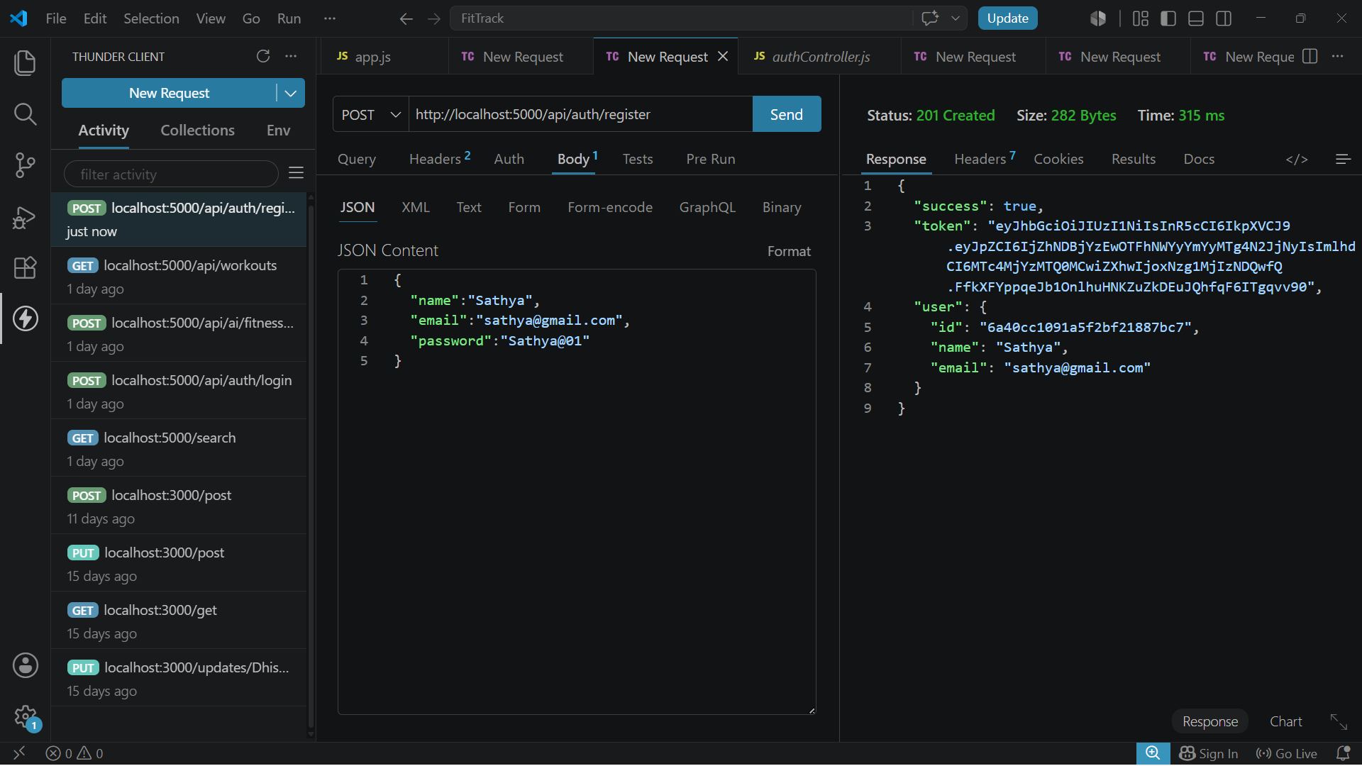

Login User

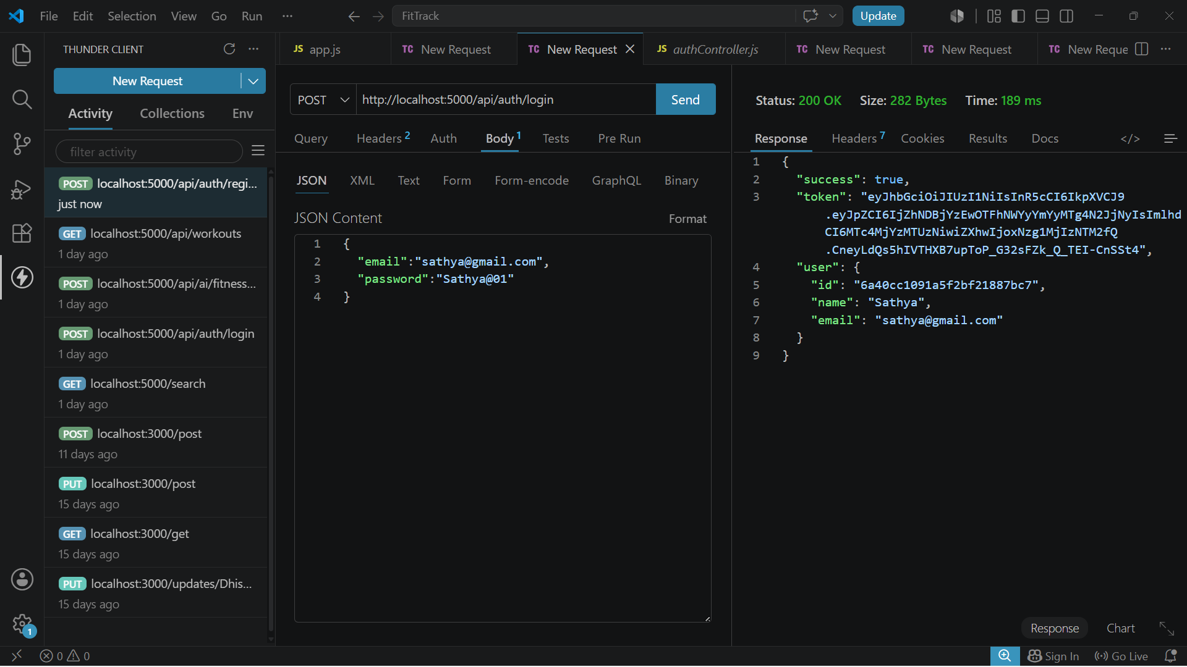

Get Profile
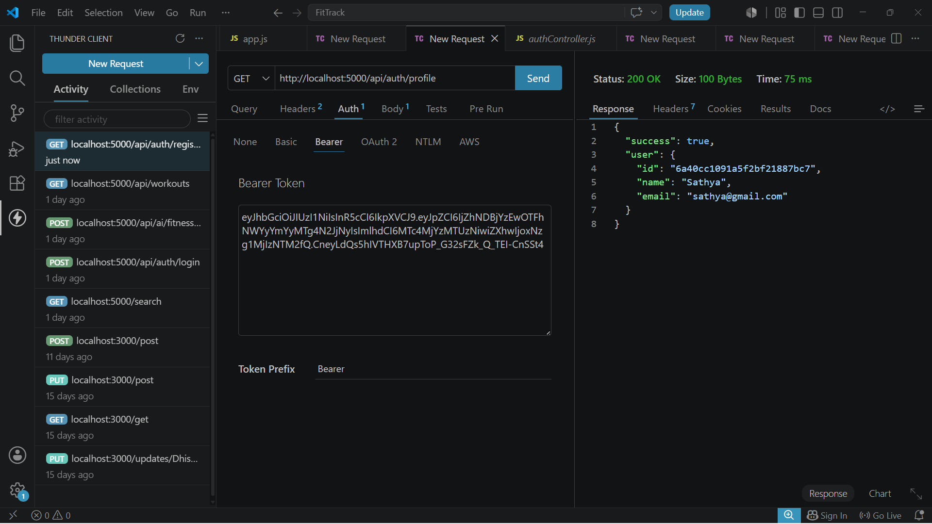
Workout API Testing

Add Workout


Get All Workouts


Get Workout By ID

Update Workout


Delete Workout

AI API Testing

Workout Recommendation


Fitness Insights



Demo Video Link: https://drive.google.com/file/d/197wQMy_tjzSebgDzVsFSlgzMybCVS1fW/view?usp=sharing

Github link:https://github.com/krishnamithal9-lang/AI-FitTrack

